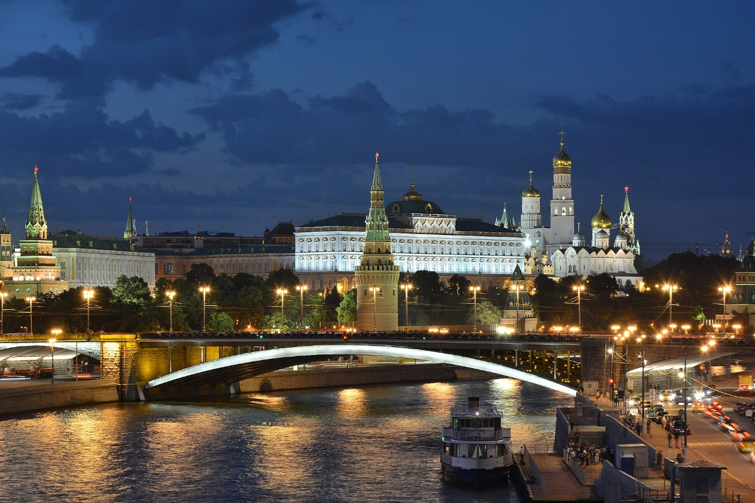

**Moscow Kremlin**

The **Moscow Kremlin**[[a]](https://en.wikipedia.org/wiki/Kremlin#cite_note-1) or simply the **Kremlin**[[b]](https://en.wikipedia.org/wiki/Kremlin#cite_note-2) is a fortified complex in [Moscow](https://en.wikipedia.org/wiki/Moscow), [Russia](https://en.wikipedia.org/wiki/Russia).[[1]](https://en.wikipedia.org/wiki/Kremlin#cite_note-3) Located in the centre of the country's capital city, it is the best known of the [kremlins](https://en.wikipedia.org/wiki/Kremlin_(fortification)) (Russian [citadels](https://en.wikipedia.org/wiki/Citadel)) and includes five palaces, four cathedrals, and the enclosing [Kremlin Wall](https://en.wikipedia.org/wiki/Moscow_Kremlin_Wall) along with the [Kremlin towers](https://en.wikipedia.org/wiki/List_of_Moscow_Kremlin_towers). Within the complex is the [Grand Kremlin Palace](https://en.wikipedia.org/wiki/Grand_Kremlin_Palace), which served as the royal residence of the [Emperor of Russia](https://en.wikipedia.org/wiki/Emperor_of_Russia). It is now the official residence of the [President of the Russian Federation](https://en.wikipedia.org/wiki/President_of_Russia). The Kremlin overlooks the [Moskva River](https://en.wikipedia.org/wiki/Moskva_(river)) to the south, [Saint Basil's Cathedral](https://en.wikipedia.org/wiki/Saint_Basil%27s_Cathedral) and [Red Square](https://en.wikipedia.org/wiki/Red_Square) to the east, and [Alexander Garden](https://en.wikipedia.org/wiki/Alexander_Garden) to the west.

The name *kremlin* means 'fortress within a city' in Russian,[[2]](https://en.wikipedia.org/wiki/Kremlin" \l "cite_note-4) and is often also used metonymically in international politics to refer to the [Government of the Russian Federation](https://en.wikipedia.org/wiki/Government_of_Russia). Likewise, during the [Cold War](https://en.wikipedia.org/wiki/Cold_War), it referred to the [Government of the Soviet Union](https://en.wikipedia.org/wiki/Government_of_the_Soviet_Union), which operated out of the city in the erstwhile [Russian SFSR](https://en.wikipedia.org/wiki/Russian_Soviet_Federative_Socialist_Republic). The term "[Kremlinology](https://en.wikipedia.org/wiki/Kremlinology)" is related to the [metonym](https://en.wikipedia.org/wiki/Metonymy) and refers to the study of Soviet and Russian politics.

Largely open to the public, the Kremlin offers supervised tours;[[3]](https://en.wikipedia.org/wiki/Kremlin#cite_note-5) the accompanying [Moscow Kremlin Museums](https://en.wikipedia.org/wiki/Moscow_Kremlin_Museums) reportedly attracted 1,024,610 visitors in 2023.[[4]](https://en.wikipedia.org/wiki/Kremlin#cite_note-6)

**History:**The site had been continuously inhabited by [Finnic peoples](https://en.wikipedia.org/wiki/Finnic_peoples" \o "Finnic peoples) (especially the [Meryans](https://en.wikipedia.org/wiki/Meryans" \o "Meryans)) since the 2nd century [BCE](https://en.wikipedia.org/wiki/Common_Era). The [Slavs](https://en.wikipedia.org/wiki/Slavs) occupied the south-western portion of [Borovitsky Hill](https://en.wikipedia.org/wiki/Kremlin_Hill" \o "Kremlin Hill) as early as the 11th century, as evidenced by a metropolitan seal from the 1090s which was unearthed by Soviet archaeologists in the area. The [Vyatichi](https://en.wikipedia.org/wiki/Vyatichi" \o "Vyatichi) built a [fortified structure](https://en.wikipedia.org/wiki/Gord_(archaeology)) (or "grad") on the hill where the [Neglinnaya River](https://en.wikipedia.org/wiki/Neglinnaya_River" \o "Neglinnaya River) flowed into the [Moskva River](https://en.wikipedia.org/wiki/Moskva_River).

Up to the 14th century, the site was known as the "grad of Moscow". The word "Kremlin" was first recorded in 1331[[5]](https://en.wikipedia.org/wiki/Kremlin#cite_note-7) (though etymologist [Max Vasmer](https://en.wikipedia.org/wiki/Max_Vasmer) mentions an earlier appearance in 1320[[6]](https://en.wikipedia.org/wiki/Kremlin#cite_note-8)). The grad was greatly extended by Prince [Yuri Dolgorukiy](https://en.wikipedia.org/wiki/Yuri_Dolgorukiy) in 1156, destroyed by the [Mongols](https://en.wikipedia.org/wiki/Mongols) in 1237 and rebuilt in oak by [Ivan I Kalita](https://en.wikipedia.org/wiki/Ivan_I_of_Moscow) in 1339.